Materials:

* Magazines
* Scissors
* 5 litters water bottle
* 1 cup Cornstarch
* 1 cup Hot water

Steps

For Magazine/s:

* 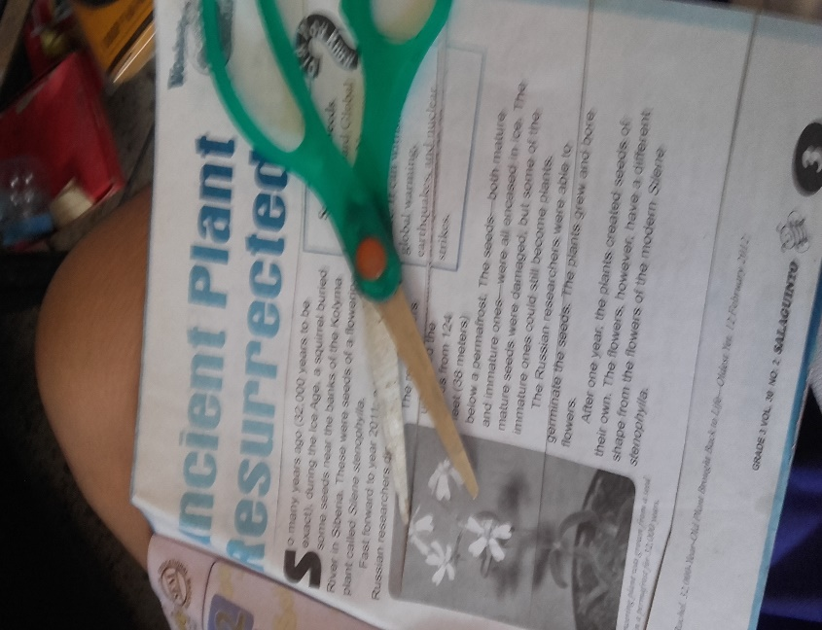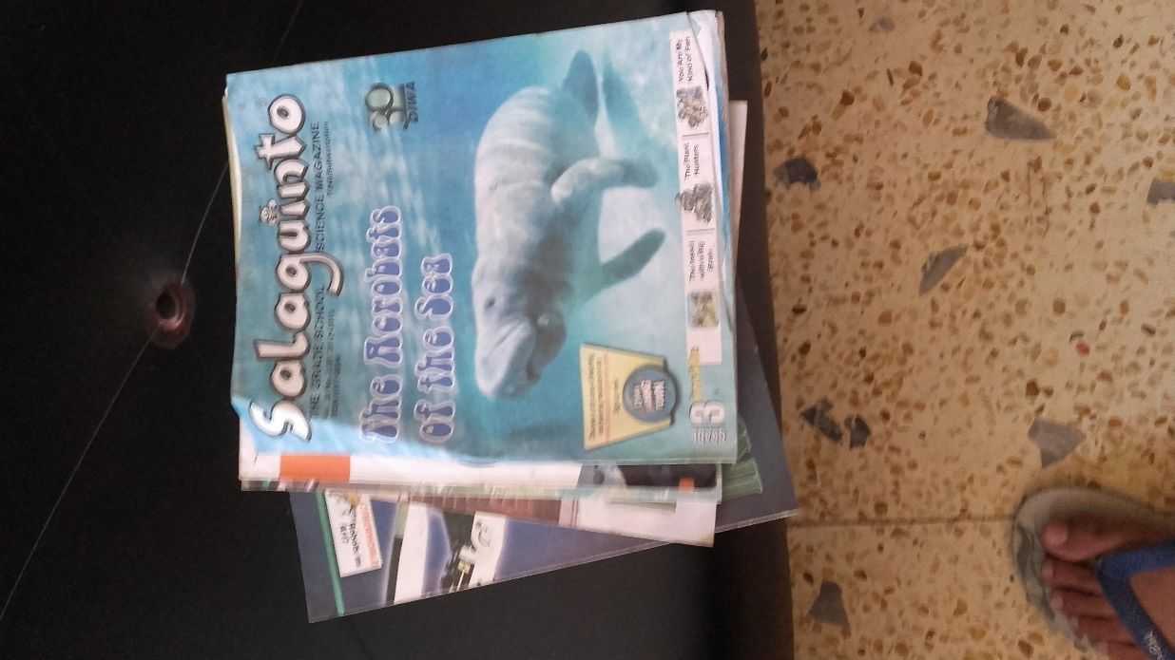Cut the magazines into strips, and set them aside for later use.

For the water bottle:

* Cut the top part of the water bottle.

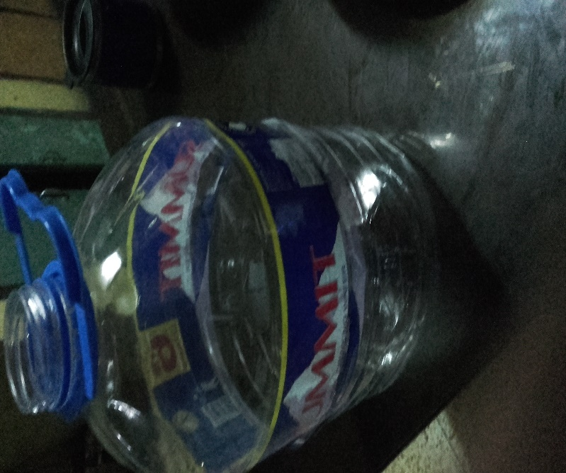

* 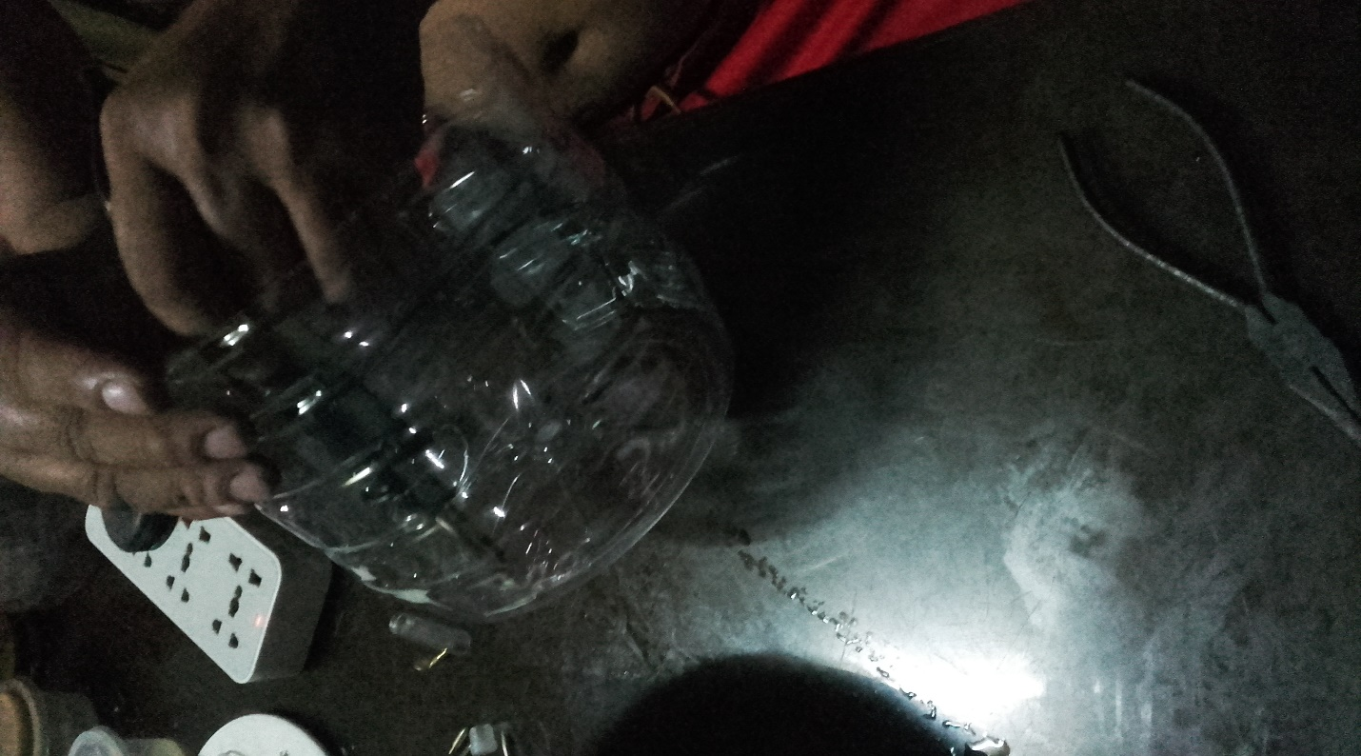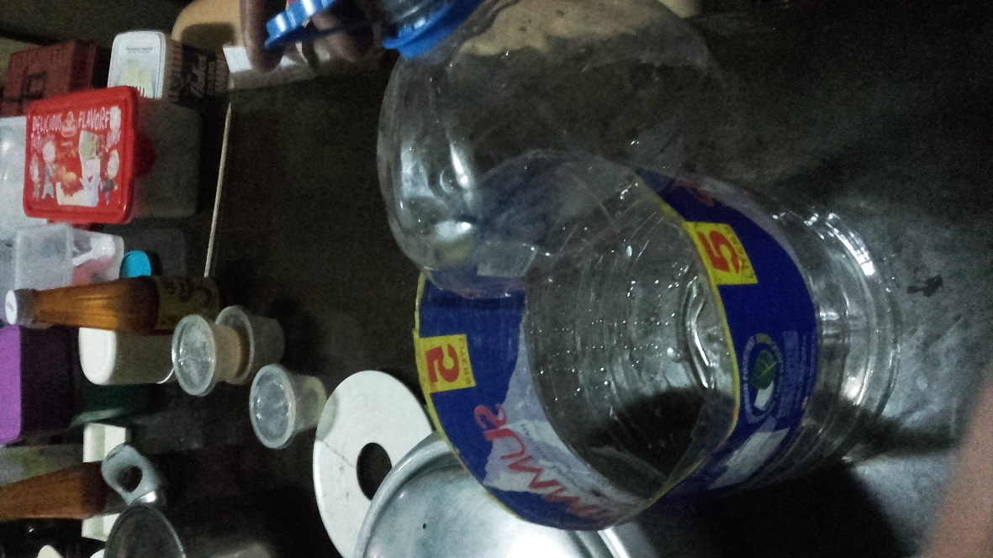Apply wholes at the bottom part of the water bottle to allow water to go through.

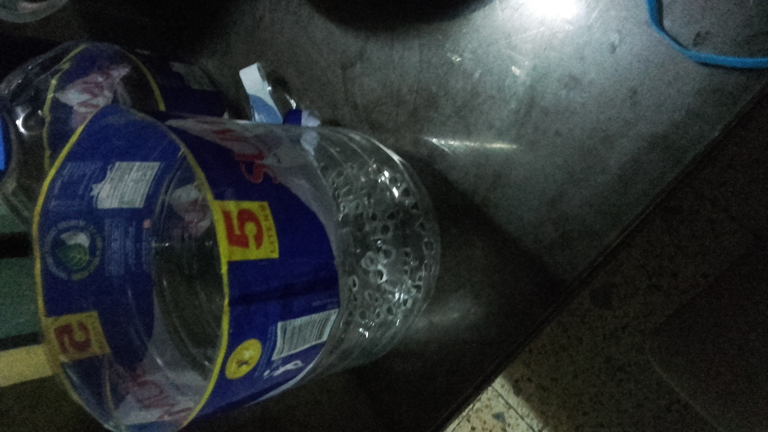

For the design:

* 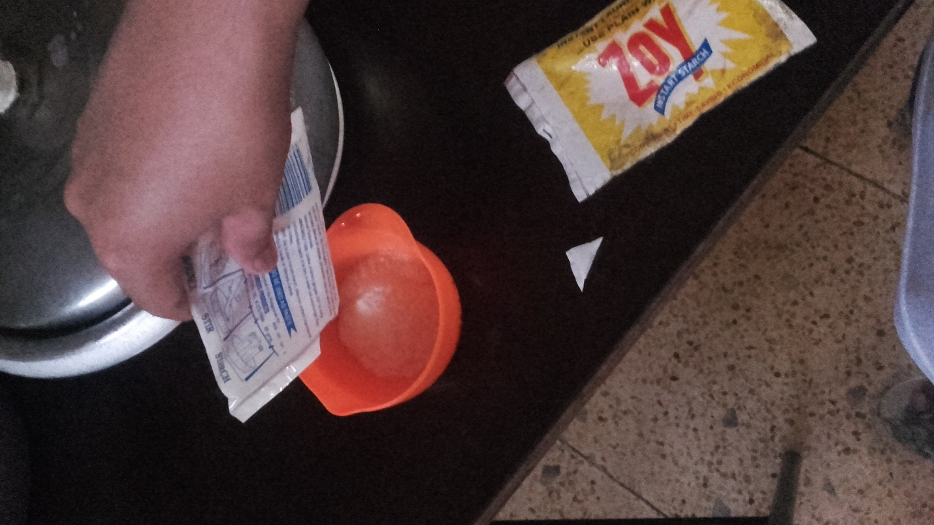Prepare 1 cup of cornstarch

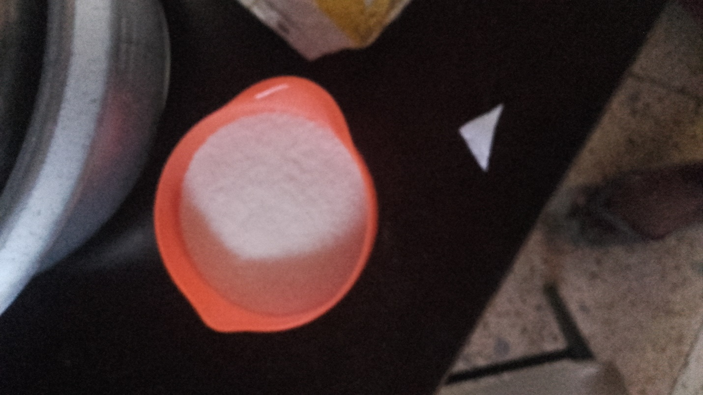

* 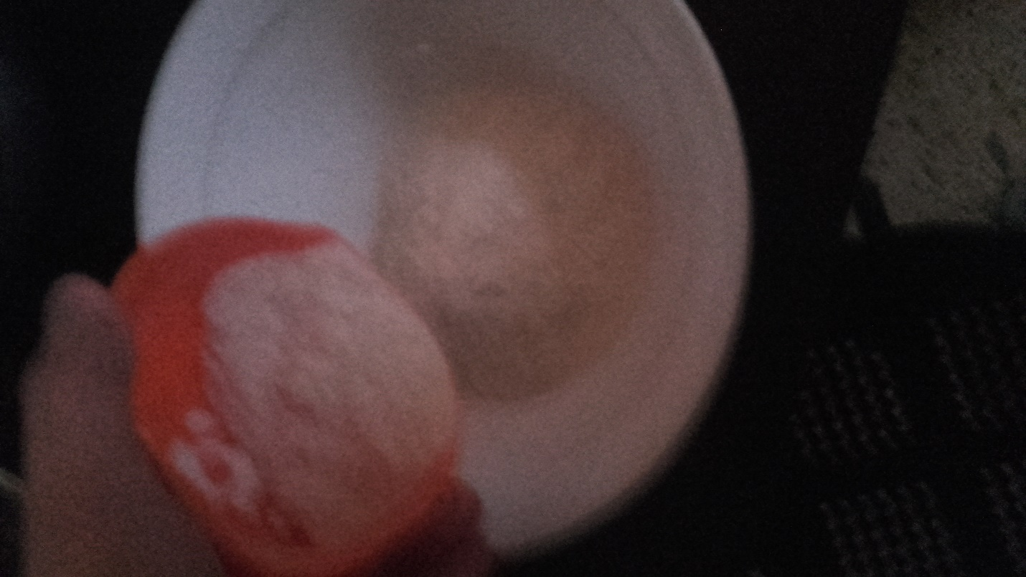Place the 1 cup of cornstarch in a mixing bowl.
* 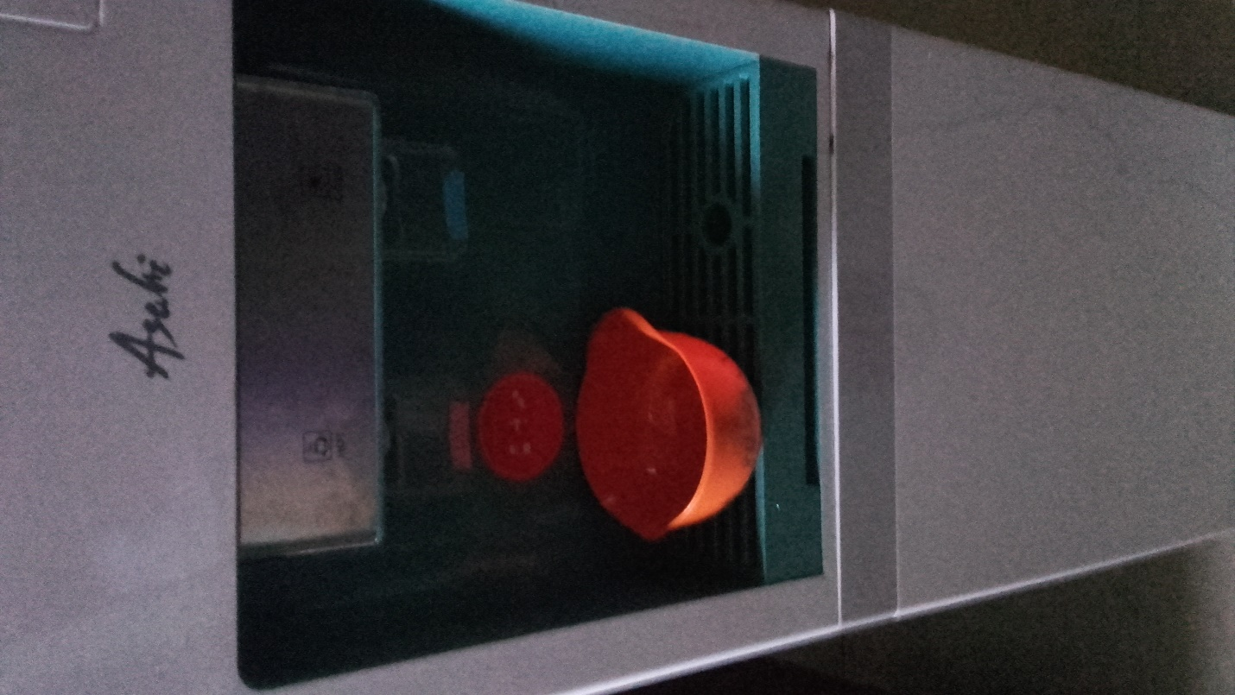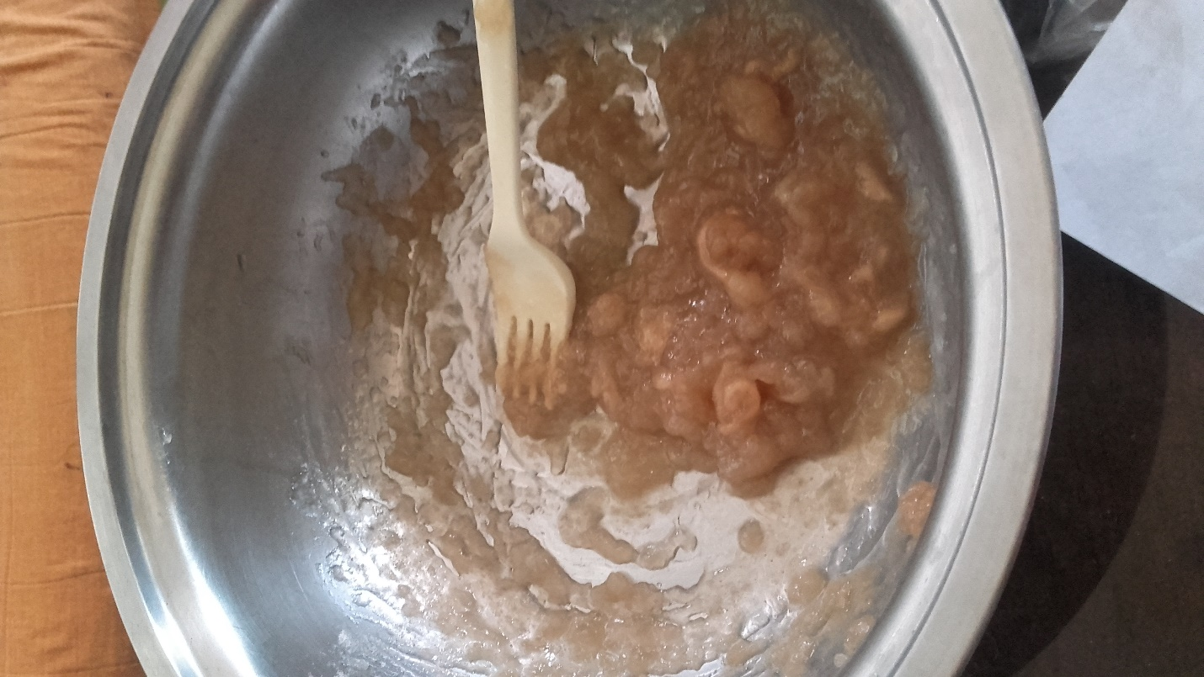Prepare 1 cup of hot water, and mix it with the cornstarch on the mixing bowl. Which will result on making an alternative paste.
* 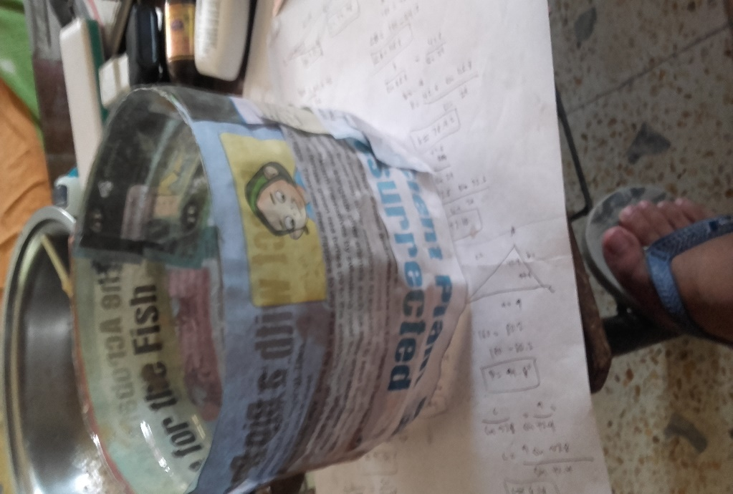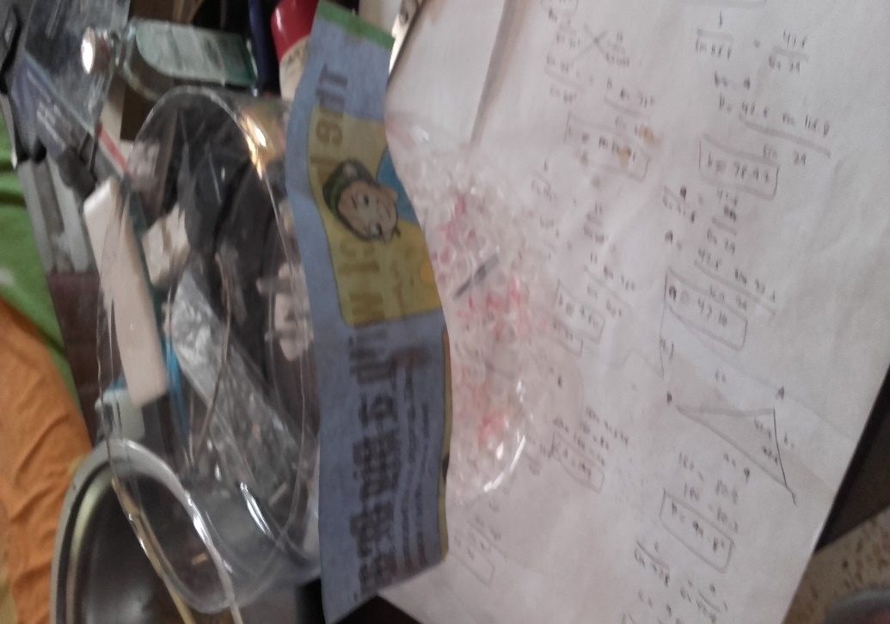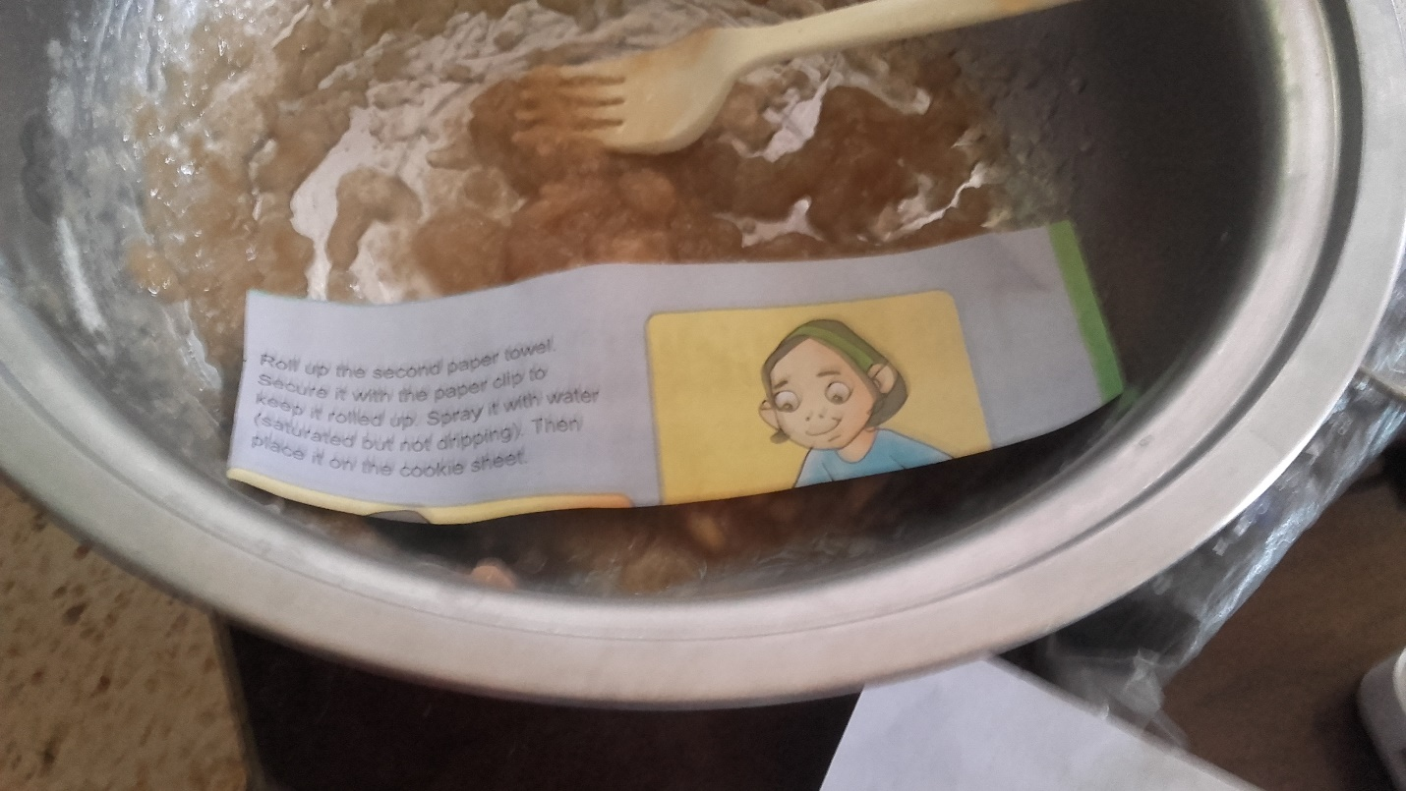Apply paste with the magazine strips, and paste them at the water bottle.
* Dry the water bottle with the pasted magazine strips for an hour or so.

